Stress
Most of us utter the phrase “I am so stressed out” multiple times a week, especially when working on assignments or preparing for final exams. Technically, however, the term stress refers to the occurrence of three separate things: a stimulus event (e.g., Lance’s father having a stroke), a process (e.g., the aftermath of realizing what the consequences of the stroke are), and a reaction (e.g., attempts to cope, actions taken to help the family recover). Each component of this chain is important in understanding what stress is and what it means in the lives of people. We will begin exploring these components one at a time, starting with the stimulus event, also known as a stressor.
Upcoming exams can be a significant source of stress for college students.

Stressors
As a personal exercise, take 60 seconds and write down everything you can remember that caused stress in your life this week. Now look at that list. You will notice that some of the items might be big deals (e.g., midterm exams week), while others may be smaller deals (e.g., your roommate snored last night, and you woke up multiple times). You also might note that some of the things on your list are regularly occurring events (e.g., your roommate left her wet towel on your bed again), while others are atypical (e.g., you lost your cell phone).
Psychologists have studied how the magnitude of a stressor or its predictability in our lives impact our reaction to these events as well as the ease with which we can adjust to such an event. While early studies of stress focused on the “life events” that caused stress for all people, such as the death of a parent or getting fired from a job (Rahe, Meyer, Smith, Kjaer, & Holmes, 1964), as the field has evolved, psychologists also began studying what we might consider to be more everyday stressors or hassles.
In the 1980s, researchers began studying daily hassles (DeLongis, Coyne, Dakof, Folkman, & Lazarus, 1982; Kanner, Coyne, Shaefer, & Lazarus, 1981). Hassles are more minor in scope but more frequent in how often they occur, like a roommate who constantly leaves dirty dishes in the sink, a friend who always texts in the middle of the night, or all your professors giving homework on a given day. Interestingly, when researchers started looking at which types of stressors—major life events versus hassles—caused more distress, they found that hassles were more problematic because of their cumulative effect.
Psychologists have categorized some stressors as acute, time-limited problems that can arise irregularly, or chronic, persistent situations that tax people’s reserves (Gottlieb, 1997; Wheaton, 1997). Wheaton (1997) defined the acute stressor as a “discrete, observable event . . . possessing a clear onset and offset” (pp. 52–53). He defined chronic stressors as “less self-limiting in nature . . . typically open ended, using up our resources in coping but not promising resolution” (p. 53). Different types of stressors can lead to different stress processes and reactions (Gottlieb, 1997) as well as differing physiological consequences. For example, an acute stressor (e.g., having your cell phone stolen) causes heightened levels of adrenaline and cortisol to be released in our bodies. These changes arm the individual’s physical system to be ready for fight or flight.
However, chronic stress, like living in poverty, from which a person does not find relief and cannot necessarily adjust, can result in more catastrophic neurological breakdowns (Compas, 2006; Romeo & McEwan, 2006). Chronic stress has even been demonstrated to have destructive effects on DNA and contribute to premature aging (Epel et al., 2004). In fact, in examining exposure to chronic racism in African Americans, researchers found that the presence of this stressor could be a significant contributor to heightened levels of physical disorders like heart disease (Clark, Anderson, Clark, & Williams, 1999). We will revisit the topic of culturally related stressors later in this chapter, but they are a powerful example of how chronic stressors can really be more damaging than acute stressors. See Researching Adjustment: Measuring Stress.

Stress Processes
Lazarus and Folkman (1984) described stress as a process that is influenced by multiple steps and emphasized that the appraisal of any given situation (i.e., stressor) was the first step in this process. Appraisal is an assessment of the situation, which has two parts. The first part, primary appraisal, determines whether the event represents a threatening situation. For example, a computer malfunction could be very threatening in the middle of an assignment but less so if it occurs over the semester break. The second step is called secondary appraisal, which factors in the person’s expectations of handling the situation.
In this secondary appraisal stage, the individual’s coping skills and other resources are taken into account and viewed as being either sufficient or insufficient in responding to the situation. For example, if the computer is fixable and the student has the money to fix it, the threat may be less severe than if it is a catastrophic meltdown requiring a new computer. Thus, the stress process is influenced by a person’s ability to deal with the environmental demands of the situation. The resulting level of distress experienced would be influenced by how successful we are in using our available resources. In this model, it is possible for one person to experience extreme levels of stress in response to an event and another person to be relatively unaffected by the same event, depending on their appraisal of the situation and their resourcefulness in responding to the event. Figure 6.1 depicts the relationship between stressors as well as primary and secondary appraisal strategies.

Stress Reactions
Reactions to stress often influence the adjustment process. Psychologists have examined the ways that people respond in the face of stressful events for many decades. Hans Selye (1956) was the first to note a particular set of physiological reactions to a variety of harmful or noxious stimuli that he called the general adaptation syndrome (GAS). Since then, stress reaction has been measured more precisely in both physiological terms, such as illness or changes in cortisol levels, or in psychological terms, such as symptoms of depression or anxiety (Derogatis & Coons, 1993).
While there are some patterns of reactions that have been observed between certain stressors and certain reactions in people, many individual differences exist that make stress reactions less predictable. For example, Gaylord-Harden, Elmore, Campbell, and Wethington (2011) studied the relationship between stressors, anxiety, and depression symptoms in African American youths. The authors found that peer relationship stressors (e.g., not getting along with friends) were positively associated with depression in African American girls, but the same stressor was associated with anxiety in African American boys. This study suggests that gender may be an important factor that determines how stress affects an individual. Gender is also a determinant of what kind of stressors a person most frequently experiences, a topic that we will revisit shortly.
In reality, perceived stress tends to have a stronger correlation with mental health outcomes than does objective measures of stress (Cohen et al., 1983). However, it is arguable that both types of measures have value. For example, it might be relevant to know that a person who experiences the death of a parent perceived that event as minimally stressful. Likewise, it might be relevant, especially to a counselor, if a person perceives an event like an argument with a friend as critically stressful. Hence, studies have utilized both types of assessment of stress, objective and subjective, depending on the focus of the study. In Table 6.2, you will find an illustration of objective versus subjective ways of measuring stress. With the objective approach, you will note that specific types of stressors have predetermined values, and regardless of how an individual experiences the stressor, it is assumed to have an inherent magnitude of impact. For example, in Table 6.2, your computer breaking down is assumed to have a more serious impact than your car breaking down, but you might imagine that for someone who is very computer-savvy and capable of repairing a computer but not a car, just the opposite could be true. The subjective approach to assessing stress allows the respondent to decide and rate accordingly how serious of an impact any given stressor might have.
Figure 6.1 Stress Processes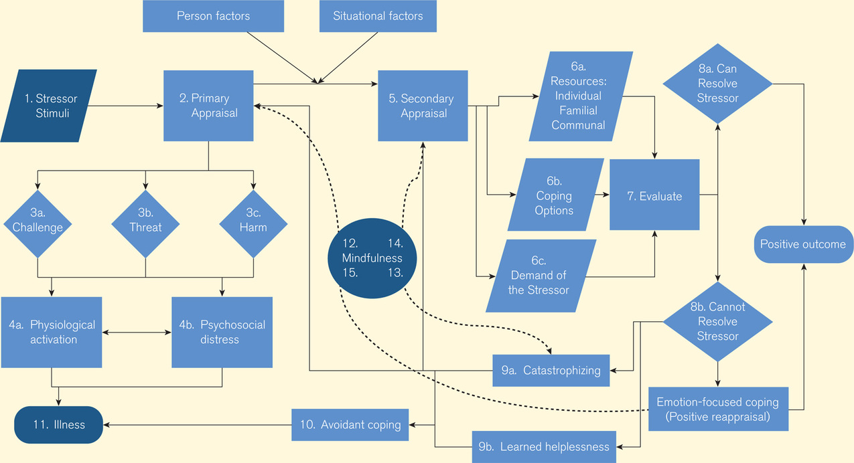
Source: Figure 1 from doi: 10.1177/1533210107301740. The Meaning of Mindfulness: A Second-Order Cybernetics of Stress, Metacognition, and Coping. Eric L. Garland. Complementary Health Practice Review, January 2007; vol. 12, 1: pp. 15–30.
Table 6.2 Objective Versus Subjective Ways to Assess Stressful Events
Table 6.2 Objective Versus Subjective Ways to Assess Stressful Events
Objective Evaluation of Stressful Events* | Points Assigned to the Stressor
1. Car breaks down | 10 points
2. Parents fight | 30 points
3. Computer stops working | 50 points
Subjective Evaluation of Stressful Events | Range of Stress to Be Determined by Rater
1. Parents are coming for a visit | Stressful 10 Neutral 5 Not at all 1
2. Argument with best friend | Stressful 10 Neutral 5 Not at all 1
3. Car breaks down | Stressful 10 Neutral 5 Not at all 1
* Note that events have a range of values depending on how much stress the individual attributes to the event.
Source: Cohen, S., Kamarck, T., Mermelstein, R. A global measure of perceived stress. Journal of Health & Social Behavior. 1983 Dec; 24(4): 385–96.

Coping
Compas (2006) described coping as a voluntary response to stressors that involves “regulation of emotion, cognition, behavior, physiology and the environment in response to stressful events or circumstances” (Compas, Connor-Smith, Saltzman, Thomsen, & Wadsworth, 2001, p. 89). As such, coping is a part of a self-regulatory process that individuals use in dealing with environmental demands or the adjustment process. Studies of coping have found a variety of ways that people frequently attempt to deal with stress. It is important to note that although people typically have more than one way to cope with any given stressful situation, it is often the case that not all coping strategies will work the same in every situation.
It is also important to remember that not all coping strategies are helpful or healthy to use. For example, some people might cope with stress by ignoring what is happening, while others will want to problem solve as a coping mechanism. Drugs and alcohol are also commonly used to cope with stressors but often hurt the person and make problems even worse. On the other hand, some people may reach out to others for support in the midst of a stressor, which is likely to be a good strategy in most cases. There are a number of effective and ineffective coping strategies, which we will examine in greater detail.

Emotion-Focused and Problem Solving–Focused Coping
Lazarus and Folkman (1984) identified two categories of coping styles that are helpful in understanding how coping works for people. Emotion-focused copingstyles

